Helene Paquet

Fashion Designer

# MY PROFILE



My name is Helene Paquet, I am a fashion designer. At a relatively young age, I worked with several well-known fashion brands. Several famous artists have used my work.



# SKILL

Creative Communication Project Management

# EDUCATION

**2009 2012 2017**

High School

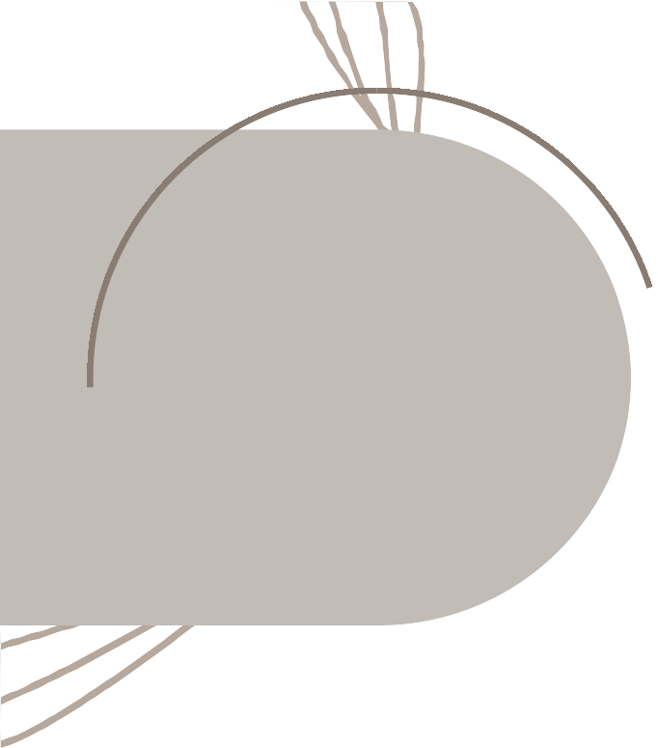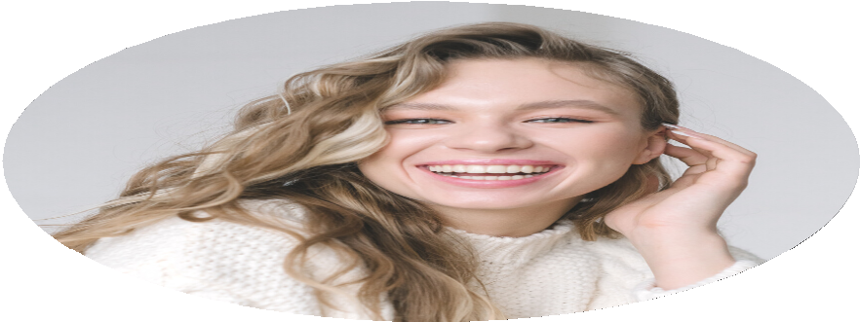

EXPERIENCE

**2017-2019**

*Fashion Stylist*

Mix and match clothes Model dress style concept

**2019-2021**

*Fashion Designer*

Choose and know about suitable fabrics and color combinations

Designing dress

CONTACT

+123-456-7890

[hello@reallygreatsite.com](mailto:hello@reallygreatsite.com) [www.reallygreatsite.com](http://www.reallygreatsite.com/)

123 Anywhere Street., Any City

of Fashion Design

Master of Fashion Borcelle University

Fashion Design Course Liceria Fashion Course