AARON

**LOEB**

CREATIVE DIRECTOR

# EXPERIENCE

**Creative Director** Borcelle Studio 2021 - 2023

Lorem ipsum dolor sit amet, consectetur adipiscing elit. Nullam pharetra in lorem at laoreet. Donec hendrerit libero eget est tempor, quis tempus arcu elementum. In elementum elit at dui tristique feugiat. Mauris convallis, mi at mattis malesuada, neque nulla volutpat dolor, hendrerit faucibus eros nibh ut nunc.

**Graphic Designer** Wardiere Studio 2018 - 2021

Lorem ipsum dolor sit amet, consectetur adipiscing elit. Nullam pharetra in lorem at laoreet. Donec hendrerit libero eget est tempor, quis tempus arcu elementum. In elementum elit at dui tristique feugiat. Mauris convallis, mi at mattis malesuada, neque nulla volutpat dolor, hendrerit faucibus eros nibh ut nunc.

**Digital Marketing** Rimberio Studio 2015 - 2018

Lorem ipsum dolor sit amet, consectetur adipiscing elit. Nullam pharetra in lorem at laoreet. Donec hendrerit libero eget est tempor, quis tempus arcu elementum. In elementum elit at dui tristique feugiat. Mauris convallis, mi at mattis malesuada, neque nulla volutpat dolor, hendrerit faucibus eros nibh ut nunc.

# EDUCATION

**Bachelor of Design** Wardiere University 2006-2008

**Master of Design** Borcelle University 2008-2010

# SKILLS

## Web Design Design Thinking

Wireframe Creation Front End Coding Problem-Solving Computer Literacy Project Management Tools

## Strong Communication

### Phone

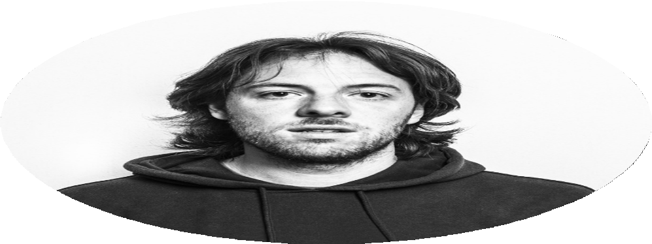

123-456-7890

### Email

[hello@reallygreatsite.com](mailto:hello@reallygreatsite.com)

### Adress

123 Anywhere St., Any City